Q.3 What is SDLC? Explain each phase of SDLC.

* SDLC:
* SDLC stand for Software Development Life Cycle.
* It’s help to creating high-quality software.
* It’s provides a well-structured flow of phases.
* Phase of SDLC:
* There are six phases of SDLC life cycle.

1. **Planning** 
   * It means requirement gathering.
   * In this phase developers will plan for the upcoming project.
2. **Analysis**

* In this phase collect information from customer like what they wants to build and what is the purpose of the project.

1. **Design**

* In this phase requirement and information used for design.
* Like make home page.
* Design helps to attract the customers.

1. **Implementation**

* Developer start the coding.
* The software design is translated into source code.
* In this phase all the components of the software are implemented.

1. **Testing & Integration**

* This phase is used to find fault in developed software.

1. **Maintenance**

* After launching the software on the environment, maintenance is required.
* Ex:- updates.

Q.4 What is DFD? Create a DFD diagram on Flipkart.

* DFD – stand for Data Flow Diagram.
* DFD represents the flow of data of a system or a process.
* DFD elements are:
* External Entity
* Process
* Data Flow
* Data Store
* There are some rules of DFD which have to be strictly followed in DFD.
* In DFD there are two processes.
* Context level (DFD level-0)
* DFD level-1 (or 2)
* DFD diagram on Flipkart:
* Zero Level DFD of Flipkart:

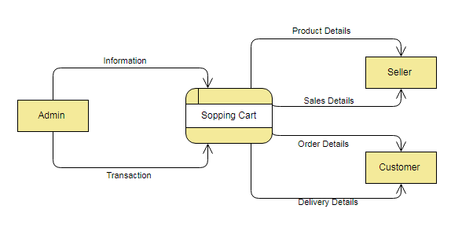

* One Level DFD of Flipkart:

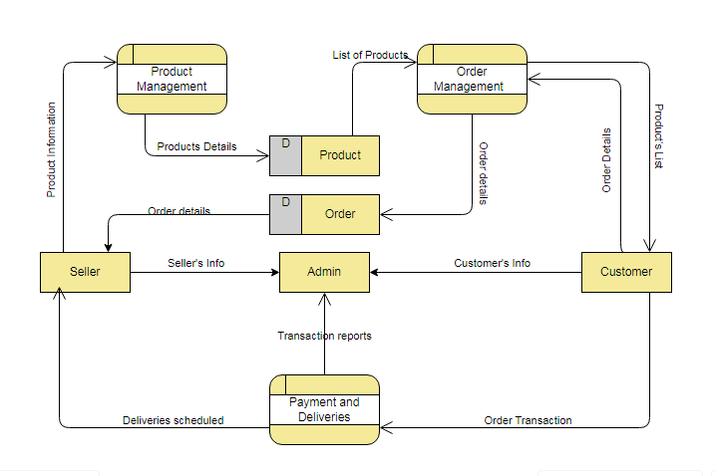

Q.5 What is Flow chart? Create a flowchart to make addition of two numbers .

* Flow chart is a set of symbols.
* It is a diagram that shows step-by-step process.
* It is a diagrammatic representation of the solution to a given problem.
* Flowchart symbol:

1. Start Or End:
2. Process:
3. Input or Output:
4. Decision making:
5. Flow lines:

* Programs can be in three format:

1. Linear or sequence
2. Branching
3. Looping

* Flow chart of Addition:

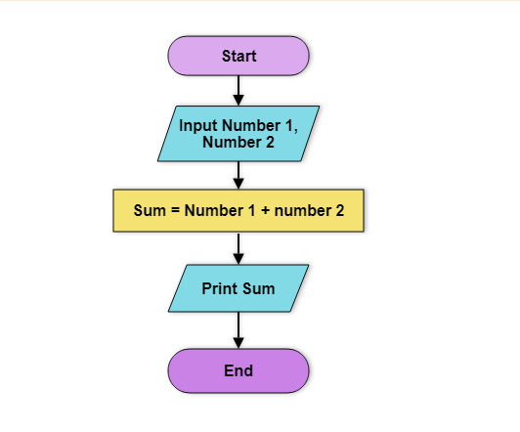

Q.6 What is Use case Diagram? Create a use-case on bill payment on paytm.

* A Use case diagram is a way to summarize details of a system and the users within that system.
* It represents an action between the user and the system.
* It provide an outside view of a system.
* Use Case Diagram of Bill Payment of Paytm:

